Name: <TYPE WRITE NAME HERE>
MATH 205
Homework 2
Work on this exam independently. Each item is worth 1 point. Type your answers below each question. Cut and paste screen shots of R Commander or the Rossman/ Chance apps onto this document. Return by March 26th NOON.

Problem 1 – The price of diamonds are influenced by 4 C’s – Carat (weight), Clarity (no natural stone imperfections), Color (no yellow or brown tones), and Cut (based on the craftsmanship of the diamond cutter). The DIAMONDS Excel file contains data for 351 diamonds, including the price each were sold.
- Numerical summaries of Total Price (Screenshot)
Ans : Min. 1st Qu. Median Mean 3rd Qu. Max.
544.1 2832.8 4762.8 7450.0 9340.9 56454.4

- Histogram of Total Price (Screenshot)
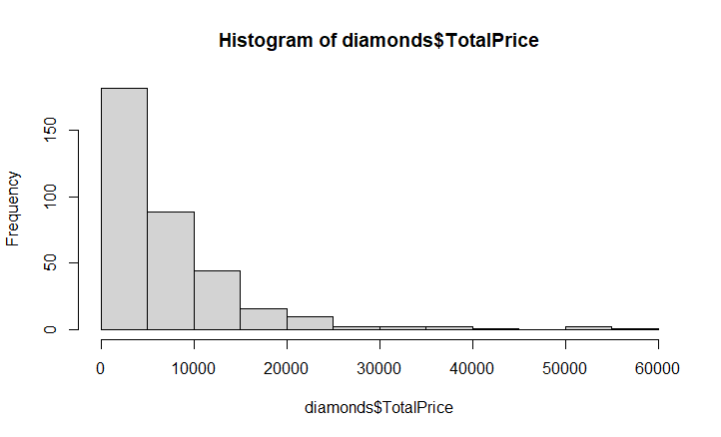

- Describe the following:
  - Shape
  - Center
  - Variability

Ans: a. Skewed Right
b. 7450.012
c. 7780.894

- Boxplot of Total Price (Screenshot)
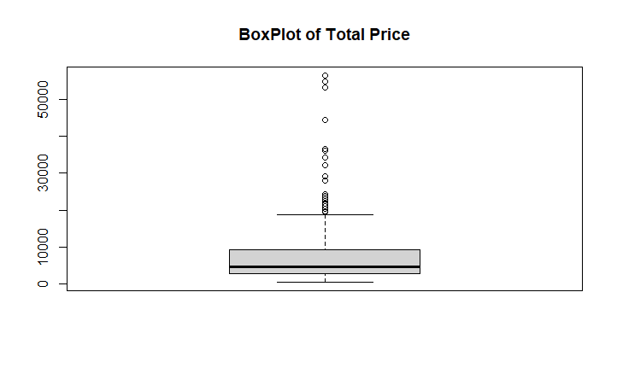

- Describe the following:
  - Shape
  - Center
  - Variability
Ans : a. Right Skewed
b. 7450.012
c. 544.1 to 56454.4
- Is the Total Price normally distributed? Use a quantile comparison plot. (Screenshot)
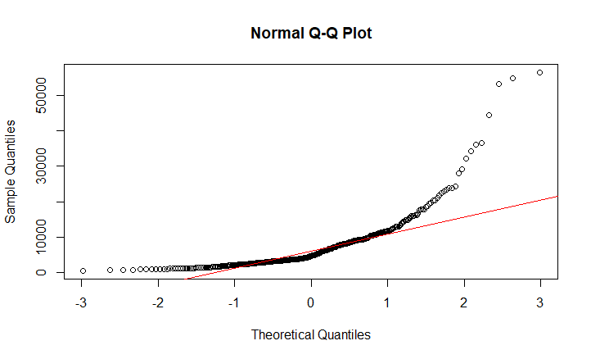
- Interpret the quantile comparison plot.
Ans : The Q-Q plot clearly shows that the quantile points do not lie on the theoretical normal line. We see that the sample values are generally lower than the normal values.

- Can we use the normal distribution to predict the range of prices for the middle 68% of diamonds? Explain.
Ans : If the data is normally distributed, the points in the QQ-normal plot lie on a straight diagonal line. Since in the above plot, data do not lie on the line, Total prices are not normally distributed.

- Why is using the mean total price as the “typical” diamond price misleading?
Ans : As the data containes many outliers, the mean should not be used as the “typical” value for diamond prices.

Problem 2 – Psychology experiments sometimes involve testing the ability of rats to navigate mazes. The mazes are classified according to difficulty, as measured by the mean length of time it takes rats to find the food at the end. One researcher needs a maze that will take rats an average of about one minute to solve. He tests one maze on several rats, collecting the data found in Maze.XLS, to check if it is not.
  - Observational units
Ans : Data containing time taken by several rats to find food at the end of maze
  - Variable of interest
Ans : $\overline{x }$=mean length of time it takes rats to find the food at the end
  - Null hypothesis/ Alternative hypotheses:
Ans : H0 : u = 60 ; rats take an average of about one minute to solve.
H1 : u != 60 ; rats does not take an average of about one minute to solve.
  - What are:
    - $\overline{x}=$ 52.20952
    - $s=$ 13.56462
    - $n=$ 21
  - Conduct a one-sample t-test. Screenshot of R Commander
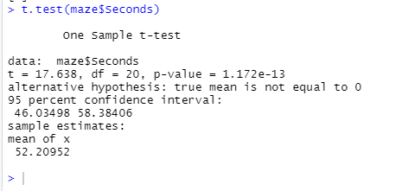
  - Why is the t-test the appropriate test for this analysis?
Ans : The test is appropriate for testing the value of a population mean when: σ is unknown, and The sample size is large (n ≥ 30) and if n < 30, the distribution must either be normal or approximately normal. Since data is approximately normal, t-test is appropriate for analysis.

  - Conclusion
Ans : Since 95% Confidence Interval contains values less than 60, we conclude that rats do not take an average of 60 seconds to solve maze
Thus we have sufficient evidence to reject null hypothesis at 5% significance level.

  - Show how to calculate the following by hand:
    - $standard error=$
    - $t-score=$
  - Can the normal distribution be used instead of the t-distribution for the results of this study? Explain.
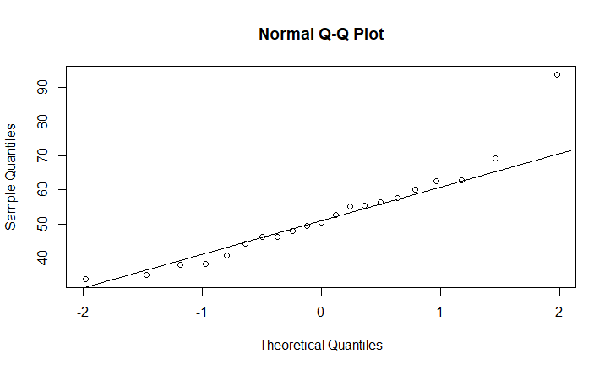
Since the values of data almost lie on the normal line, we can say that data is approximately normally distributed.

Problem 3 – A medical journal reported on an experiment intended to see if a certain drug could be used as a treatment for the eating disorder anorexia nervosa. The subjects were randomly divided into two groups. Of the 98 who received this drug, 70 were deemed healthy a year later, compared to 50 of the 88 who got the placebo.
- What is the population for this study?
Ans: People having eating disorder anorexia nervosa.
- Is this an experimental study? Explain.
Experimental studies involve the random assignment of -participants into different groups in order to determine the causal effect of a certain condition on a certain outcome. Here participants who have eating disorder are divided into groups drugs and placebo to test the outcome.
- What is the explanatory variable?
Ans : Here, the explanatory variable is the total number of people having eating disorder that are treated with drug and placebo.
- What is the response variable?
Ans : Here, the response variable is the proportion of people that were deemed healthy after a year of treating with drug and placebo.

- Complete the 2x2 table of counts.

 | Drug | Placebo | Total
Healthy after a year | 70 | 50 | 120
Not healthy | 28 | 38 | 66
Total | 98 | 88 | 186
Proportion healthy | 70/98 = 0.7142857 | 50/88= 0.5681818 | 120/186= 0.6451613

- What is $π_{Drug}-π_{Placebo}$?
Ans : 0.1461039

- What are the null/ alternative hypotheses?
Ans : H0 : Drug and Placebo both have same results for treating the disorder.
H1 : Drug and Placebo do not have same results for treating the disorder.

- Calculate the p-value using simulation (Sampling from two-process)? (Screenshot)
Ans : p-value = 0.05413
- Conduct a two-sample proportion test on R Commander. Create your own Excel file. (Screenshot)
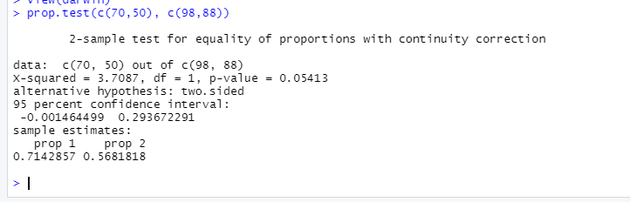
- Interpret the 95% confidence interval.
Ans : 95 percent confidence interval:
-0.001464499 0.293672291

- Calculate a p-value using simulation (Randomization test for categorical response)? (Screenshot)

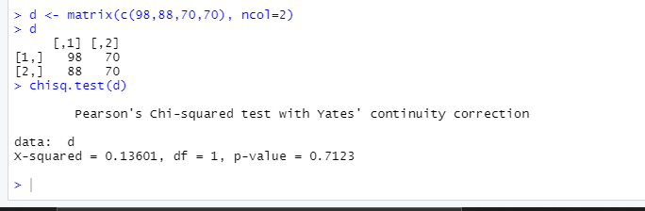
p vale = 0.7123

- Conclusion (Reduction argument)
Ans : As p value in both cases is greater than 0.05, we do not have sufficient evidence to reject null hypothesis.
Thus we conclude that, Drug and Placebo both have same results for treating the disorder.

